Title: | < Door Control Module >  SW Component < CRC8 >

History
Issue status  (Index) | Maturity/Date  (draft/invalid/valid)  (dd-mmm-yyyy) | Author  Department | Check/Release  Department | Description
1.0 | Draft  31-Jan-21 | Marco Antonio Romo Ramírez | - | Creation of the document

Table of Contents
1 Purpose 3
2 Definitions and abbreviations 3
3 Realization constraints and targets 3
4 SW Conceptual design 3
5 SW Component internal breakdown 4
5.1 Functional Decomposition 4
5.2 Function <Type> <function name> (type par 1, .., type par n) 5
5.3 Function <Type> <function name> (type par 1, .., type par n) 5

Purpose
This document shows the corresponding interfaces of the CRC8 software component. This component will handle all the logic necessary to generate the cyclic redundancy check algorithm

Definitions and abbreviations
Definitions
NA

Abbreviations
CRC Cyclic Redundancy Check
References
N° | Document name | Reference
1 | SW Architecture | Commit:
 |  | ddc45822a03f9f1781eaa4fc5b6d5874311f8e1b [ddc4582]

Realization constraints and targets

The CRC 8 component has the objective of generating the cyclic redundancy algorithm and returning it to the CANServices component

SW Conceptual design

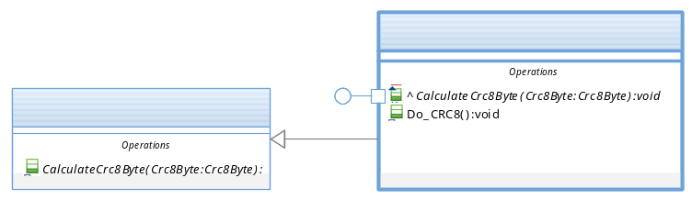

SW Component internal breakdown

Functional Decomposition
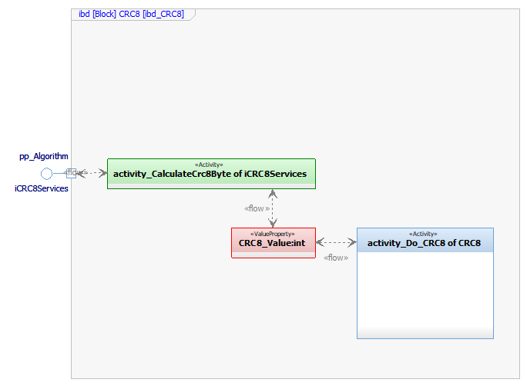

Function Void activity_Do_CRC8()

Description | This function is in charge of calculating the CRC8
Parameter 1  <input| output| inout> | NA – Does not use parameters.
Parameter 2..n | NA – Does not use parameters.
Return Value | NA – Does not return a value.
Precondition | e.g. Function can only be called in a certain state, SW component is initialized  Relation between input parameters where applicable (Input for Module Test)
Post condition | e.g. specific State change e.g. car is locked, EEPROM Values written,  Relation between output parameters where applicable
Error Conditions
Requirements

Function Void activity_CalculateCrc8Byte(Crc8Byte* Crc8Byte)
Description | This function is called by activity_Do_CRC8 () SWC to update the value of the CRC8_Value variable.
Parameter 1  <input| output| input> | Crc8Byte* Crc8Byte <input>
Parameter 2..n
Return Value
Precondition | e.g. Function can only be called in a certain state, SW component is initialized  Relation between input parameters where applicable (Input for Module Test)
Post condition | e.g. specific State change e.g. car is locked, EEPROM Values written,  Relation between output parameters where applicable
Error Conditions
Requirements

